Data Visualization Presentation

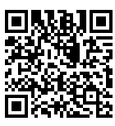

Link: [*https://rpubs.com/CUAMMNETWORKSHOP/1334280*](https://rpubs.com/CUAMMNETWORKSHOP/1334280)

Machine Learning Models Presentation

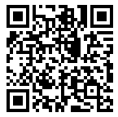

Link:[*https://rpubs.com/CUAMMNETWORKSHOP/1334276*](https://rpubs.com/CUAMMNETWORKSHOP/1334276)